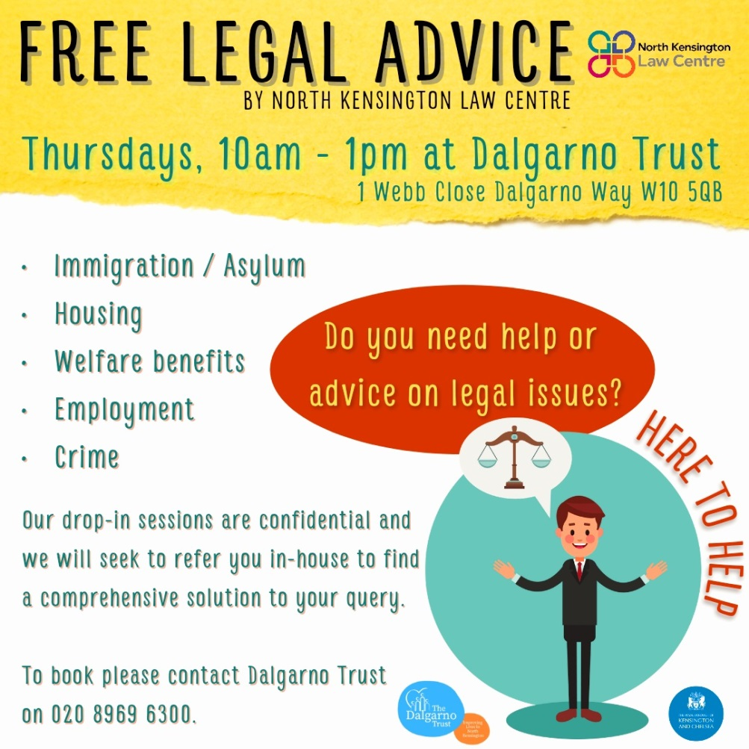
Free legal advice by North Kensington Law Centre
Thursdays -10-1 at Dalgarno Trust - 1 Webb Close, Dalgarno Way W10 5QB
Do you need help on legal issues?
- Immigration / Asylum
- Housing
- Welfare Benefits
- Employment
- Crime
Our drop-in sessions are confidential and we will seek to refer you in-house to find a comprehensive solution to your query. To book, please contact Dalgarno Trust on 020 8969 3600

