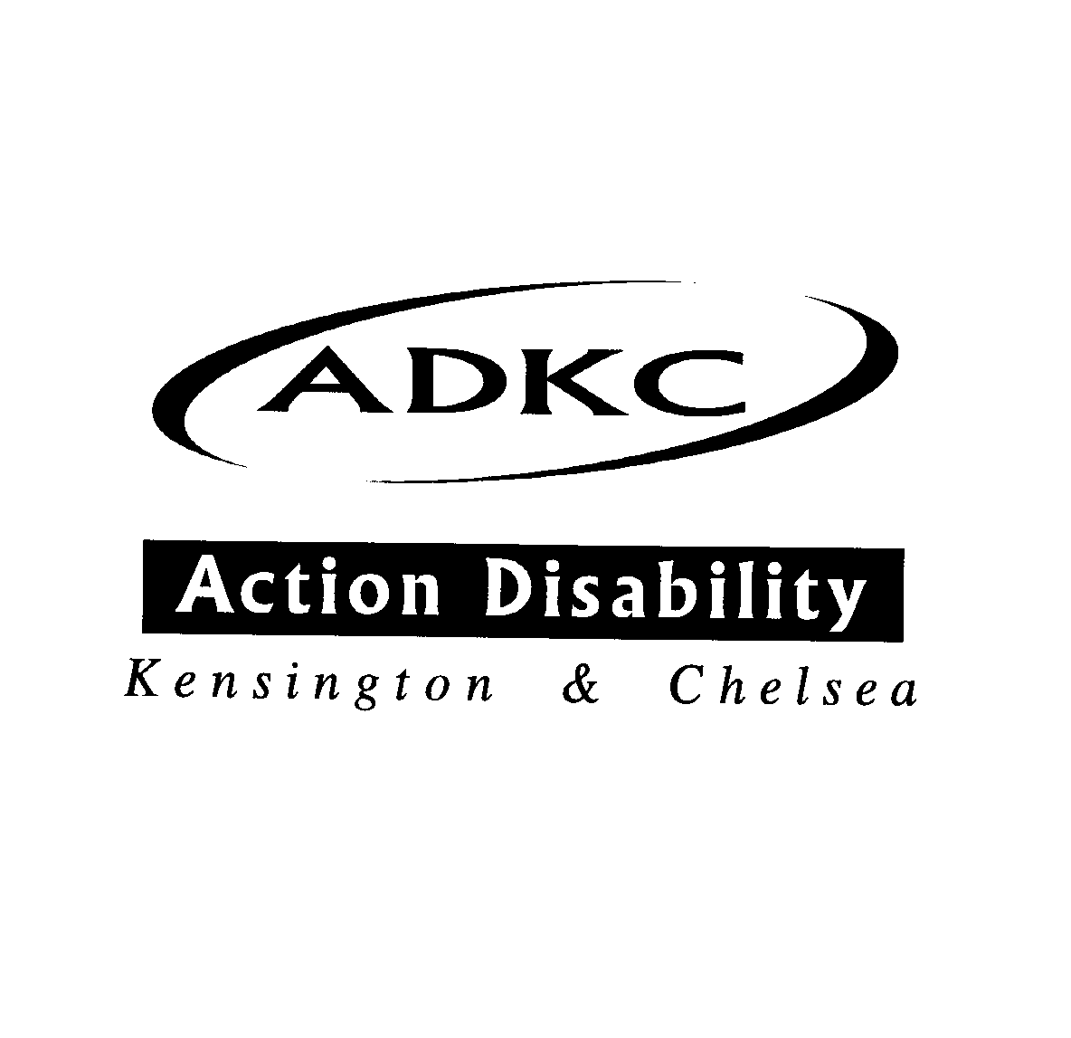

**Please contact Martha to RSVP or if you need support to use Zoom**

**Email:** [**Pbadmin@adkc.org.uk**](mailto:Pbadmin@adkc.org.uk)

**Phone/Text: 07928821346**

The Chair & Executive Committee of

**Action Disability Kensington & Chelsea**

Request the pleasure of your company at their

Annual General Meeting

Special Guest Speaker: Jon Abrams (Inclusion London) “Inspiring Activism”

Presentation from ADKC’s Access Group

On Thursday 3rd December 2020

4.00pm – 5.00pm

Via Zoom

Invite Link: <https://us02web.zoom.us/j/85326084658?pwd=RkFCdHdlMnBDNEd6SUR5dCtTaTloUT09>